
MATHEMATICS METHODS 4
SEMESTER 2 2018
INVESTIGATION 2
Earthquakes
Marks: 42 Time: 50 minutes

In this Investigation, any answer without sufficient reasoning will not be awarded full marks.
We know the Richter scale reading, R, is a measure of the magnitude of seismic waves from an earthquake. It was devised in 1935 by the seismologist Charles F. Richter (1900–1985) and technically known as the local magnitude scale, such that
R = $log$ $\frac{I}{I_{0}}$
Where $I_{0}$ is the minimum intensity used for comparison.

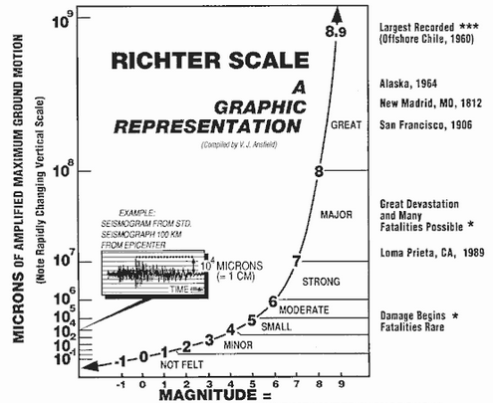
1. a) What is the magnitude, R, for an earthquake of intensity 50$I_{0}$? [1]

b) How would you describe the intensity of this earthquake?
[1]

c) An earthquake measures 5.5 on the Richter scale. Write the intensity in terms of $I_{0}$.
[2]

d) Determine a formula or rule that could be used to determine how many times more intense a measure of R₁ on the Richter scale is than R_{2.} Demonstrate your formula with an example.
[4]

e) A new age seismologist, Holanderi, thought that since earthquakes were a naturally occurring phenomena then the formula should use natural logarithms.
i.e. H = ln$\left[\frac{I}{I_{0}}\right]$
Using this scale, an earthquake measuring 7.2 on the Holanderi scale is how many times as intense as that of one measuring 5.2 on the Holanderi scale?
[2]

f) A particularly strong earthquake measuring R on the Richter scale is measured in Japan. What is H in terms of R?
[5]

The Moment Magnitude scale $M_{w}$ was developed to succeed the 1930's-era Richter magnitude scale.
Although the Richter scale was used to measure the size of earthquakes in terms of the energy released, The Moment Magnitude scale looked at exactly how an earthquake released its energy through factors such as the depth of the fault, the force required to move the fault and how dense the rock around the fault was.
The moment magnitude has no units and is defined as
$$M_{w}=\frac{2}{3}\log_{10}\left(M_{0}\right)-10.7$$
where $M_{0}$ is the total amount of energy that is transformed during an earthquake, measured in dyn$∙$cm.

2. a) On 28 June 2016, an estimated $2.82×{10}^{21}$ dyn∙cm of energy was transformed during an earthquake near Norseman, WA. Calculate the moment magnitude for this earthquake.
[2]

b) A few days later, on 8 July 2016, there was another earthquake with moment magnitude 5.2 just north of Norseman. Calculate how much energy was transformed during this earthquake.
[3]

c) Had this been 5.3 rather than 5.2, what can you say about the amount of energy that is transformed?
[3]

(d) Show that an increase of 2 on the moment magnitude scale corresponds to the transformation of 1000 times more energy during an earthquake.
[6]

Worldwide there are far more low magnitude than high magnitude earthquakes. The table below shows how the average annual frequency of earthquakes varies with magnitude. These figures are based on observations since 1900.

Description | Magnitude | Average Annual Frequency
Great Earthquakes | 8 or more | 1
Major Earthquakes | 7 – 7.9 | 18
Strong Earthquakes | 6 – 6.9 | 120
Moderate Earthquakes | 5 – 5.9 | 800
Light Earthquakes | 4 – 4.9 | 6 200 (estimated)
Minor Earthquakes | 3 – 3.9 | 49 000 (estimated)
Very Minor Earthquakes | 2 – 2.9 | approx 1 000 per day
Very Minor Earthquakes | 1 – 1.9 | approx 8 000 per day
Data Source: US National Earthquake Information Centre

A relationship has been discovered between the magnitude of earthquakes and their frequency of occurrence. This relationship is called the Gutenberg-Richter formula. This relationship has been found to apply to particular regions as well as to the world as a whole.

3. a) Complete the following table where N denotes the number of earthquakes per year with magnitude greater than or equal to M.

M | N | log₁₀ N
8
7
6
5
4
3
2
1
[4]

b) Draw a graph of log₁₀ N against M.
[4]

c) Use your graph to describe the type of function that best describes the relationship between N and M, and determine the function.

[5]

